**Batch: D - 1 Roll No.: 16010122096**

**Experiment No. 11**

|  |
| --- |
| **TITLE**: Write a program to draw “Buckyball” using openGL library. |

**AIM:**

Write a program to draw “Buckyball” using openGL library.

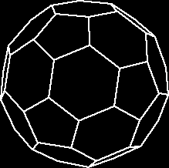**______________________________________________________________________**

**Expected OUTCOME of Experiment:**

You should see a rotating Buckyball rendered in 3D on your screen, with different colors for each face.

**_____________________________________________________________________**

**Books/ Journals/ Websites referred:**

* **https://www.opengl.org/**
* **https://learnopengl.com/**

**_____________________________________________________________________**

**Algorithm/ Pseudocode for each process:**

### Algorithm:

1. **Initialize OpenGL:**
   * Set display mode using glutInitDisplayMode().
   * Create the window with glutCreateWindow().
   * Set up the viewport using glViewport().
   * Configure projection matrix with gluPerspective().
   * Initialize the modelview matrix using glLoadIdentity().
2. **Define Buckyball Vertices:**
   * Precompute or define the 60 vertices of the Buckyball (truncated icosahedron).
   * Store the vertices in an array or data structure.
3. **Draw the Buckyball:**
   * For each of the 32 faces (12 pentagonal and 20 hexagonal):
     + Begin polygon definition using glBegin(GL_POLYGON).
     + For each face, use corresponding vertices from the array to create pentagons or hexagons.
     + End polygon definition with glEnd().
4. **Set Rendering Options:**
   * Set colors and enable lighting for visualization.
   * Configure shading model using glShadeModel().
   * Enable depth testing using glEnable(GL_DEPTH_TEST) for correct rendering.
5. **User Interaction:**
   * Implement keyboard and/or mouse input handlers to allow:
     + Rotation of the Buckyball.
     + Zoom in/out functionality.
6. **Start Rendering Loop:**
   * Call glutMainLoop() to enter the event handling and rendering loop.

**Implementation details:**

**#include <GL/glut.h>**

**#include <cmath>**

**GLfloat xRotated, yRotated, zRotated;**

**void display(void);**

**void idle(void) {**

**xRotated += 0.01;**

**yRotated += 0.01;**

**zRotated += 0.01;**

**display();**

**}**

**void myinit() {**

**GLfloat mat_specular[] = { 1.0, 1.0, 1.0, 1.0 };**

**GLfloat mat_shininess[] = { 50.0 };**

**GLfloat light_position[] = { 1.0, 1.0, 1.0, 0.0 };**

**glMaterialfv(GL_FRONT, GL_SPECULAR, mat_specular);**

**glMaterialfv(GL_FRONT, GL_SHININESS, mat_shininess);**

**glLightfv(GL_LIGHT0, GL_POSITION, light_position);**

**glEnable(GL_LIGHTING);**

**glEnable(GL_LIGHT0);**

**glEnable(GL_DEPTH_TEST);**

**}**

**void display(void) {**

**glClearColor(1, 1, 1, 1);**

**glClear(GL_COLOR_BUFFER_BIT | GL_DEPTH_BUFFER_BIT);**

**glMatrixMode(GL_MODELVIEW);**

**glLoadIdentity();**

**glTranslatef(0.0, 0.0, -5.0);**

**glColor3f(0.9, 0.3, 0.2);**

**glRotatef(xRotated, 1.0, 0.0, 0.0);**

**glRotatef(yRotated, 0.0, 1.0, 0.0);**

**glRotatef(zRotated, 0.0, 0.0, 1.0);**

**glutSolidDodecahedron();**

**glFlush();**

**}**

**void myReshape(GLsizei w, GLsizei h) {**

**glViewport(0, 0, w, h);**

**glMatrixMode(GL_PROJECTION);**

**glLoadIdentity();**

**glOrtho(-1.5, 1.5, -1.5 * (GLfloat)h / (GLfloat)w, 1.5 * (GLfloat)h / (GLfloat)w, -10.0, 10.0);**

**glMatrixMode(GL_MODELVIEW);**

**glLoadIdentity();**

**}**

**int main(int argc, char** argv) {**

**glutInit(&argc, argv);**

**glutInitWindowSize(640, 480);**

**glutInitWindowPosition(200, 200);**

**glutInitDisplayMode(GLUT_SINGLE | GLUT_RGBA | GLUT_DEPTH);**

**xRotated = 30.0;**

**yRotated = 50.0;**

**glutCreateWindow("Bucky ball");**

**glutDisplayFunc(display);**

**glutReshapeFunc(myReshape);**

**myinit();**

**glutIdleFunc(idle);**

**glutMainLoop();**

**return 0;**

**}**

**Output:**

**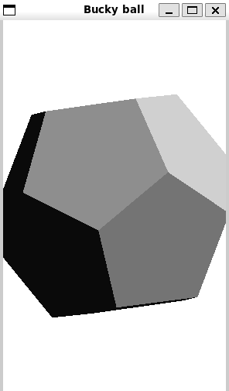  
  
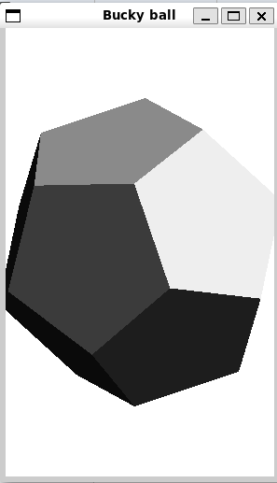**

**Conclusion and discussion:**

We successfully drew a Buckyball using OpenGL, applying 3D geometry, rendering techniques, and user interaction to visualize the structure efficiently with lighting and color effects.

**Date: Signature of faculty in-charge**

**Post Lab**

**Draw The 5-, 11-, and 17-rosettes. using OpenGL.**

**#include <GL/glew.h>**

**#include <GLFW/glfw3.h>**

**#include <cmath>**

**const float PI = 3.14159265358979323846f;**

**void drawRosette(int n, float radius, int num_points = 100) {**

**glBegin(GL_LINE_LOOP);**

**for (int i = 0; i < num_points; ++i) {**

**float angle = 2.0f * PI * i / num_points;**

**float r = radius * (1 + 0.5f * sin(n * angle));**

**float x = r * cos(angle);**

**float y = r * sin(angle);**

**glVertex2f(x, y);**

**}**

**glEnd();**

**}**

**void renderScene() {**

**glClear(GL_COLOR_BUFFER_BIT);**

**glColor3f(1.0f, 1.0f, 1.0f); // Set color to white**

**//Draw 5-rosette**

**drawRosette(5, 0.5f);**

**// Translate to the right for 11-rosette**

**glPushMatrix();**

**glTranslatef(1.5f, 0.0f, 0.0f);**

**drawRosette(11, 0.5f);**

**glPopMatrix();**

**// Translate to the right for 17-rosette**

**glPushMatrix();**

**glTranslatef(3.0f, 0.0f, 0.0f);**

**drawRosette(17, 0.5f);**

**glPopMatrix();**

**}**

**int main() {**

**// Initialize GLFW**

**if (!glfwInit()) {**

**return -1;**

**}**

**// Create a windowed mode window and its OpenGL context**

**GLFWwindow* window = glfwCreateWindow(800, 600, "Rosettes", nullptr, nullptr);**

**if (!window) {**

**glfwTerminate();**

**return -1;**

**}**

**glfwMakeContextCurrent(window);**

**glewInit();**

**while (!glfwWindowShouldClose(window)) {**

**renderScene();**

**glfwSwapBuffers(window);**

**glfwPollEvents();**

**}**

**glfwDestroyWindow(window);**

**glfwTerminate();**

**return 0;**

**}**

**5 rosettes  
  
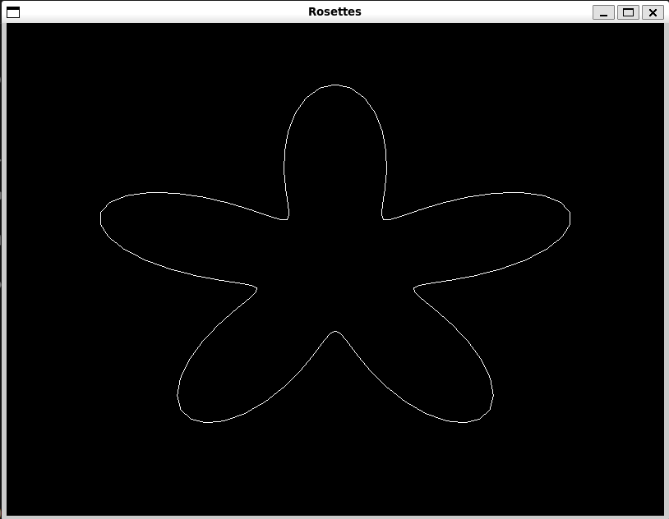  
  
11rosettes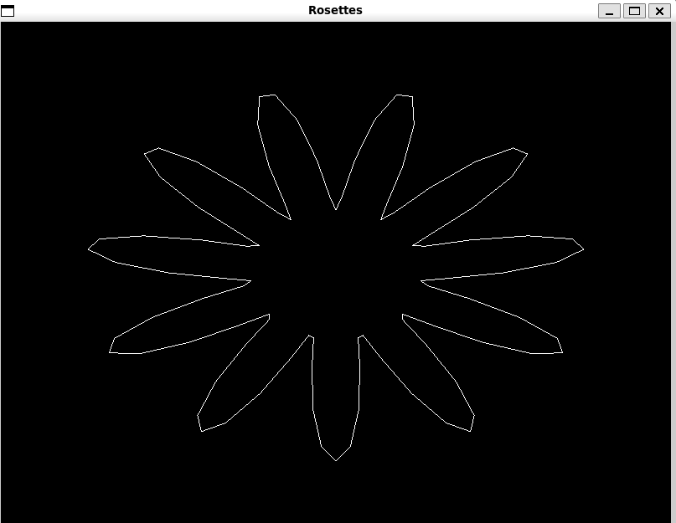  
  
17 rosettes  
